Documentation of Russian Mafia

-Sergey Alekseevich Toptunov 10b class - scrum trainer

-Evgeniy Dmitrievich Kresnov 10v class – backend developer

-Anastasiya Artyomovna Gorska 10a class – frontend developer

-Grigoriy Evgenievich Kalashnik 10b class – backend developer

-Lev Eduardovich Davletov 10a class – backend developer

1.Our goals

-Our goal was to create a termochemical calculator

-The issue was the algorithm for finding molecular mass and the solution was to initialise the index too.

2.Main stages

-On 20.10.2023 our team assembled

-On 25.10.2023 we decided on the subject

-On 08.11.2023 the code was finished

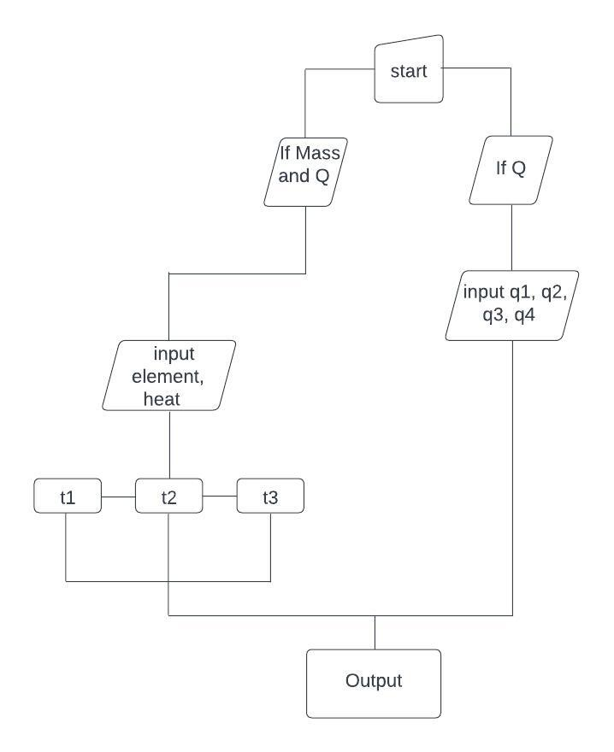

3.Outcome

The code allows you to find details of chemical elements.

The app itself can be upgraded with visual illustrations and animations.